# Part 4

*What is the Body effect?*

The Body effect of a transistor, is created when a voltage is appplied between the source and body, making a fourth terminal, this effect is mainly based on the size of the transistor. This fourth terminal increases the charge reguired to shift the channel, thereby increasing the threshold voltage(Vth).

An additional effect that increasing Vth has is determining a transistors pass characteristics. Nmos transistors pass 1’s poorly, making the voltage level off the 1 Vdd- Vth this fall in voltage can potentially violate the noise margins off the transistor especially in circuits with low voltage. For Pmos transistors it has the opposite effect making them pass 0’s poorly.

*How can body biasing affect the speed of a circuit?*

To answer this we take a standard pseudo-nmos circuit.

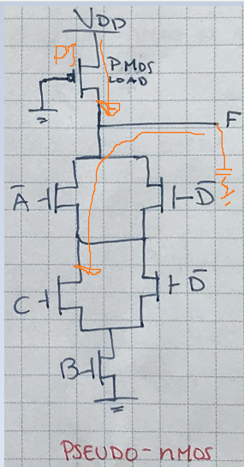

Figur 1: Standard Pseudo-Nmos

As we can see in the circuit the NMOS area is open, and the circuit is trying to discharge the load. However the PMOS transistor P1 is always on and therefore always trying to charge the load. Whether we are discharging or charging is therefore determined by which current is stronger. Therefore the circuit must be made so that the NMOS’s have a stronger current, to discharge, but even if this is the case, the size and therefore amount of current P1 can draw, will affect the speed that the NMOS transistors can discharge the load. So often this PMOS must be smaller so that the performance of the circuit is maintained.